**Compte Rendu Séquence n°2 :**

**Exercice 1 : Découverte de MySQL et JDBC**

On va utiliser le schéma du TD n°3 « La base Cling Clang & Co ». On a d’abord réalisé sur papier le schéma entité association pour pouvoir le simplifier au maximum. En effet on sait que lorsque les cardinalités sont *,1 on peut fusionner entité/association.

Schéma.

On fusionne les associations et les tables. Si l’on fait ça, deux entités vont être reliées par un traits, or dans un schéma entité/association on ne peut pas relié 2 entités ensembles. C’est pour cela que l’on utilise EER.

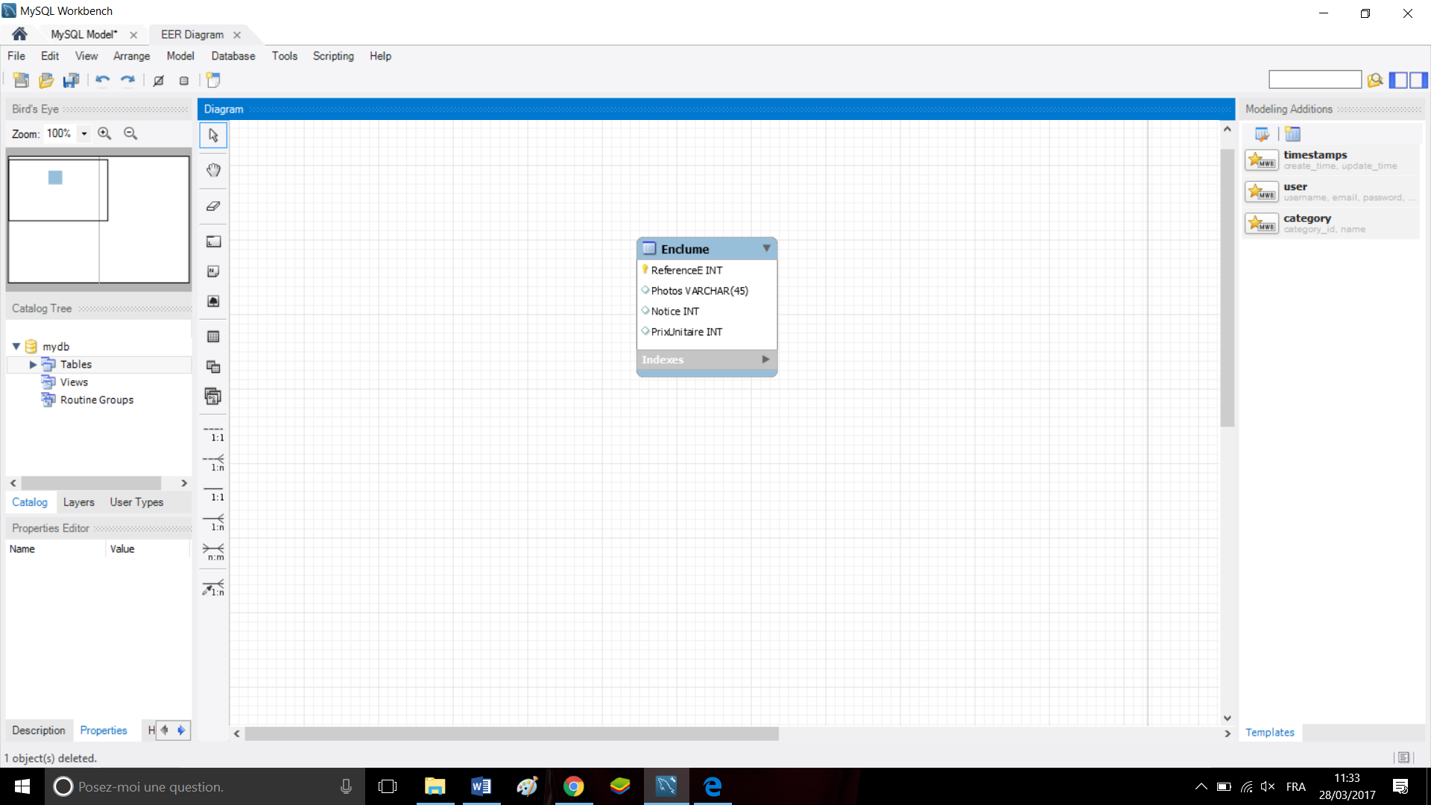

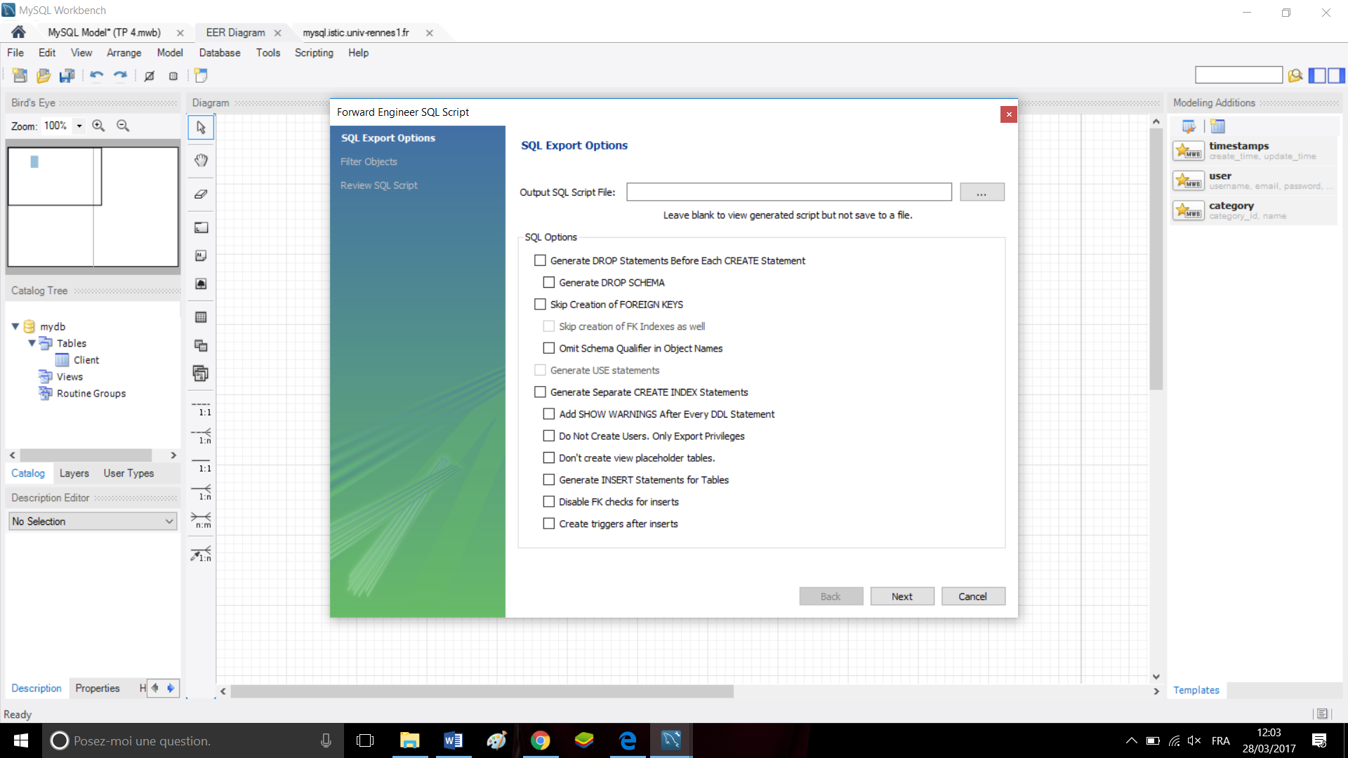

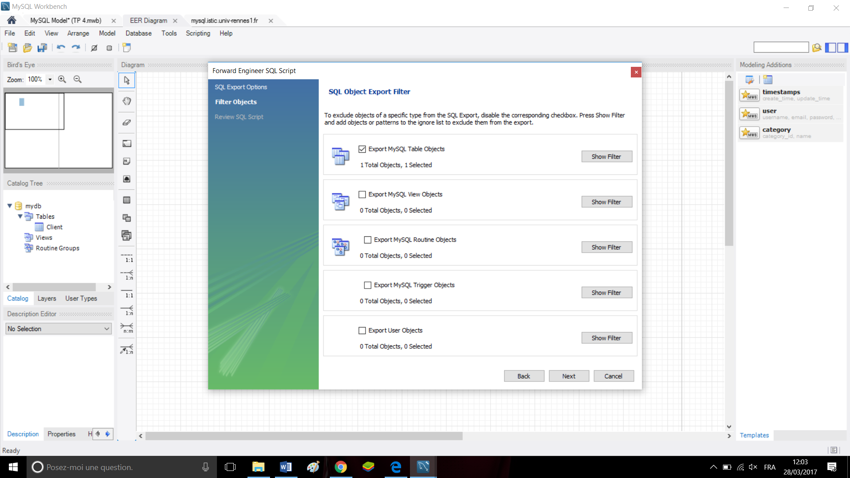

-- MySQL Script generated by MySQL Workbench

-- Tue Mar 28 11:58:51 2017

-- Model: New Model Version: 1.0

-- MySQL Workbench Forward Engineering

SET @OLD_UNIQUE_CHECKS=@@UNIQUE_CHECKS, UNIQUE_CHECKS=0;

SET @OLD_FOREIGN_KEY_CHECKS=@@FOREIGN_KEY_CHECKS, FOREIGN_KEY_CHECKS=0;

SET @OLD_SQL_MODE=@@SQL_MODE, SQL_MODE='TRADITIONAL,ALLOW_INVALID_DATES';

-- -----------------------------------------------------

-- Schema base_17011240

-- -----------------------------------------------------

-- -----------------------------------------------------

-- Schema base_17011240

-- -----------------------------------------------------

CREATE SCHEMA IF NOT EXISTS `base_17011240` DEFAULT CHARACTER SET utf8 ;

USE `base_17011240` ;

-- -----------------------------------------------------

-- Table `base_17011240`.`Client`

-- -----------------------------------------------------

CREATE TABLE IF NOT EXISTS `base_17011240`.`Client` (

`idClient` INT NOT NULL,

`adresse` TEXT NULL,

`CP` INT NULL,

`Ville` TEXT NULL,

PRIMARY KEY (`idClient`))

ENGINE = InnoDB;

SET SQL_MODE=@OLD_SQL_MODE;

SET FOREIGN_KEY_CHECKS=@OLD_FOREIGN_KEY_CHECKS;

SET UNIQUE_CHECKS=@OLD_UNIQUE_CHECKS;

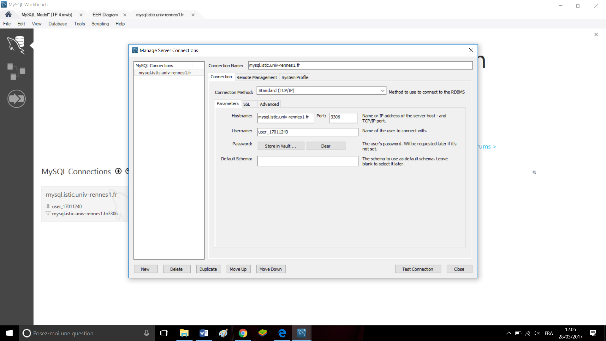

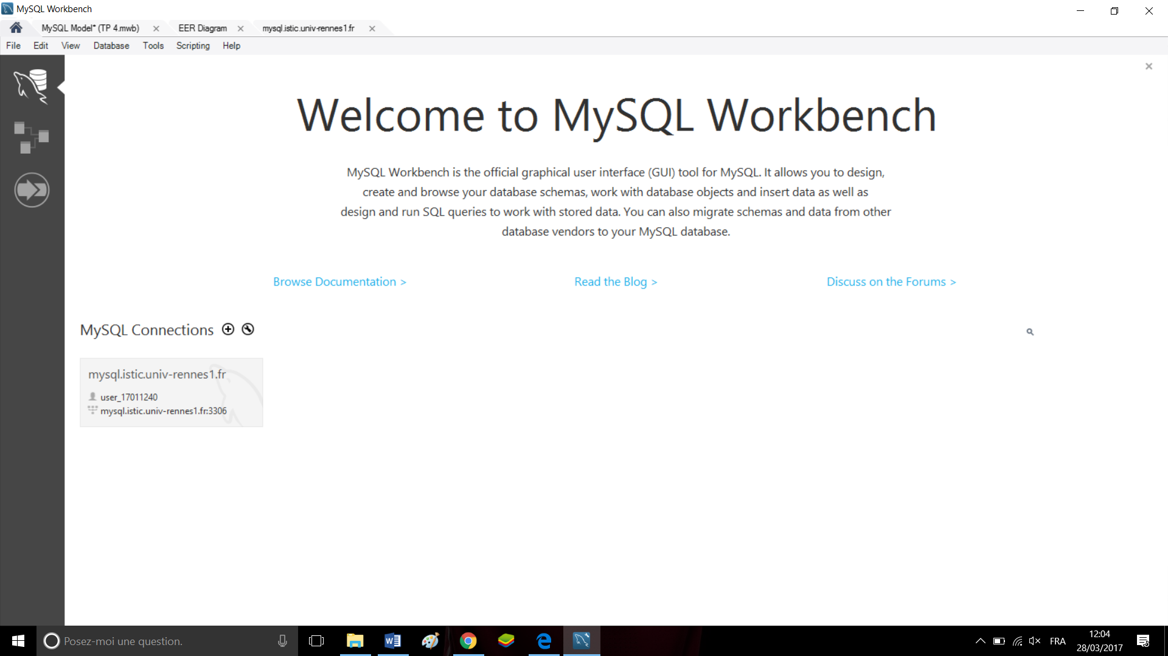

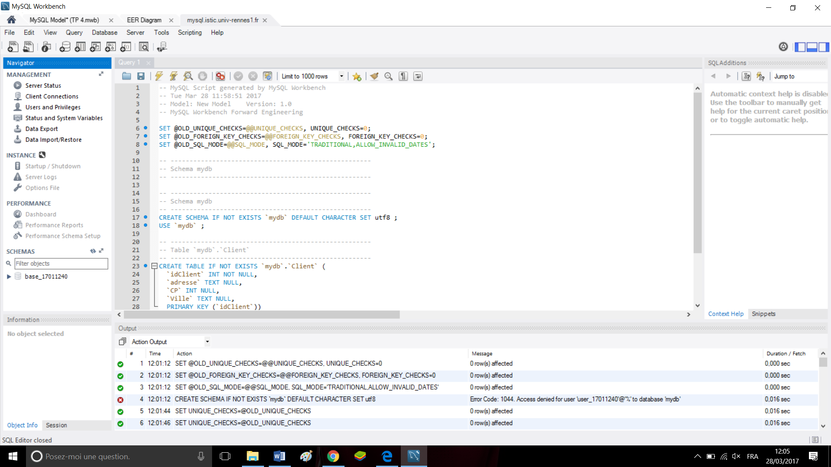

-- MySQL Script generated by MySQL Workbench

-- Tue Apr 4 14:44:30 2017

-- Model: New Model Version: 1.0

-- MySQL Workbench Forward Engineering

SET @OLD_UNIQUE_CHECKS=@@UNIQUE_CHECKS, UNIQUE_CHECKS=0;

SET @OLD_FOREIGN_KEY_CHECKS=@@FOREIGN_KEY_CHECKS, FOREIGN_KEY_CHECKS=0;

SET @OLD_SQL_MODE=@@SQL_MODE, SQL_MODE='TRADITIONAL,ALLOW_INVALID_DATES';

-- -----------------------------------------------------

-- Schema base_17011240

-- -----------------------------------------------------

-- -----------------------------------------------------

-- Schema base_17011240

-- -----------------------------------------------------

CREATE SCHEMA IF NOT EXISTS `base_17011240` DEFAULT CHARACTER SET utf8 ;

USE `base_17011240` ;

-- -----------------------------------------------------

-- Table `base_17011240`.`Client`

-- -----------------------------------------------------

CREATE TABLE IF NOT EXISTS `base_17011240`.`Client` (

`idClient` INT NOT NULL,

`adresse` TEXT NULL,

`CP` INT NULL,

`Ville` TEXT NULL,

`Nom` TEXT NULL,

PRIMARY KEY (`idClient`))

ENGINE = InnoDB;

-- -----------------------------------------------------

-- Table `base_17011240`.`Facture`

-- -----------------------------------------------------

CREATE TABLE IF NOT EXISTS `base_17011240`.`Facture` (

`idFacture` INT NOT NULL,

`Ristourne` INT NULL,

`idSource` INT NULL,

PRIMARY KEY (`idFacture`))

ENGINE = InnoDB;

-- -----------------------------------------------------

-- Table `base_17011240`.`Commande`

-- -----------------------------------------------------

CREATE TABLE IF NOT EXISTS `base_17011240`.`Commande` (

`idCommande` INT NOT NULL,

`idPanier` INT NULL,

`Facture_idFacture` INT NOT NULL,

`Client_idClient` INT NOT NULL,

PRIMARY KEY (`idCommande`, `Facture_idFacture`, `Client_idClient`),

INDEX `fk_Commande_Facture1_idx` (`Facture_idFacture` ASC),

INDEX `fk_Commande_Client1_idx` (`Client_idClient` ASC),

CONSTRAINT `fk_Commande_Facture1`

FOREIGN KEY (`Facture_idFacture`)

REFERENCES `base_17011240`.`Facture` (`idFacture`)

ON DELETE NO ACTION

ON UPDATE NO ACTION,

CONSTRAINT `fk_Commande_Client1`

FOREIGN KEY (`Client_idClient`)

REFERENCES `base_17011240`.`Client` (`idClient`)

ON DELETE NO ACTION

ON UPDATE NO ACTION)

ENGINE = InnoDB;

-- -----------------------------------------------------

-- Table `base_17011240`.`Enclume`

-- -----------------------------------------------------

CREATE TABLE IF NOT EXISTS `base_17011240`.`Enclume` (

`idEnclume` INT NOT NULL,

`Photos` TEXT NULL,

`Poids` INT NULL,

`Taille` INT NULL,

`Prix` INT NULL,

PRIMARY KEY (`idEnclume`))

ENGINE = InnoDB;

-- -----------------------------------------------------

-- Table `base_17011240`.`Produit`

-- -----------------------------------------------------

CREATE TABLE IF NOT EXISTS `base_17011240`.`Produit` (

`Enclume_idEnclume` INT NOT NULL,

`Commande_idCommande` INT NOT NULL,

`Qte` INT NULL,

PRIMARY KEY (`Enclume_idEnclume`, `Commande_idCommande`),

INDEX `fk_Enclume_has_Commande_Commande1_idx` (`Commande_idCommande` ASC),

INDEX `fk_Enclume_has_Commande_Enclume_idx` (`Enclume_idEnclume` ASC),

CONSTRAINT `fk_Enclume_has_Commande_Enclume`

FOREIGN KEY (`Enclume_idEnclume`)

REFERENCES `base_17011240`.`Enclume` (`idEnclume`)

ON DELETE NO ACTION

ON UPDATE NO ACTION,

CONSTRAINT `fk_Enclume_has_Commande_Commande1`

FOREIGN KEY (`Commande_idCommande`)

REFERENCES `base_17011240`.`Commande` (`idCommande`)

ON DELETE NO ACTION

ON UPDATE NO ACTION)

ENGINE = InnoDB;

SET SQL_MODE=@OLD_SQL_MODE;

SET FOREIGN_KEY_CHECKS=@OLD_FOREIGN_KEY_CHECKS;

SET UNIQUE_CHECKS=@OLD_UNIQUE_CHECKS;

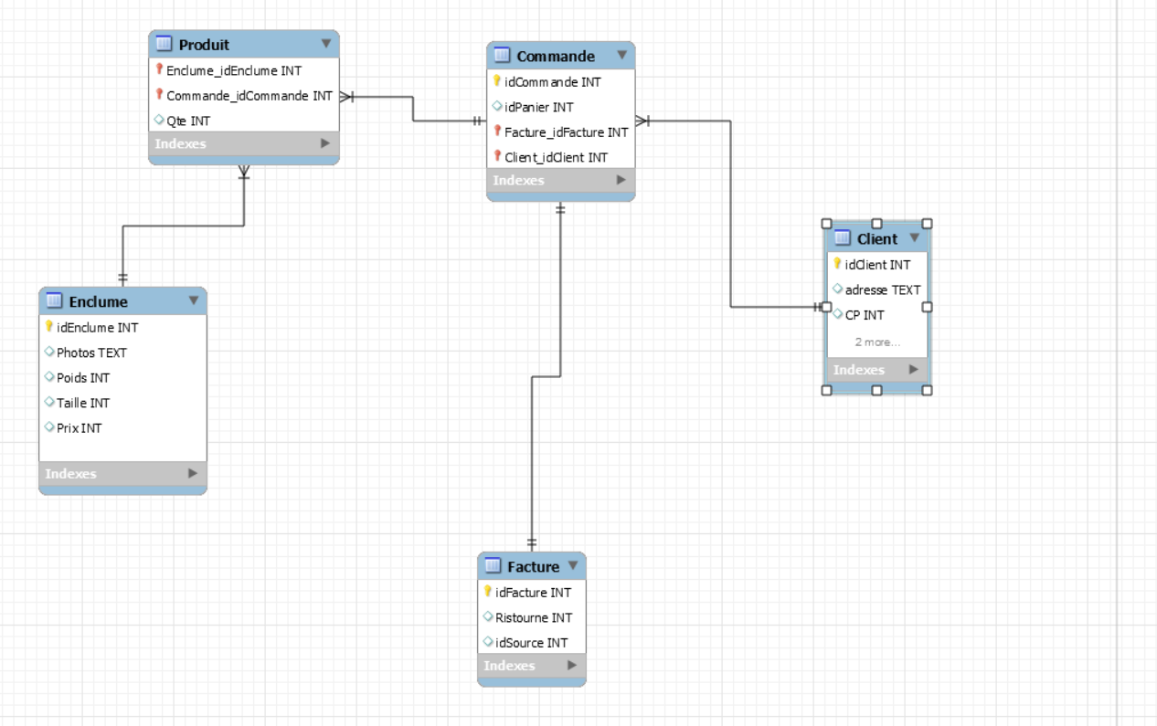

INSERT INTO `base_17011240`.`Client` (`idClient`, `adresse`, `CP`, `Ville`, `Nom`) VALUES ('1', 'rue dantrain', '35700', 'Rennes', 'Guilpain');

INSERT INTO `base_17011240`.`Client` (`idClient`, `adresse`, `CP`, `Ville`, `Nom`) VALUES ('2', 'rue des champs', '69000', 'Lyon', 'Greco');

INSERT INTO `base_17011240`.`Client` (`idClient`, `adresse`, `CP`, `Ville`, `Nom`) VALUES ('3', 'rue de la ville', '49000', 'Angers', 'Robin');

INSERT INTO `base_17011240`.`Client` (`idClient`, `adresse`, `CP`, `Ville`, `Nom`) VALUES ('4', 'rue de la foret', '14000', 'Caen', 'Legris');

INSERT INTO `base_17011240`.`Enclume` (`idEnclume`, `Photos`, `Poids`, `Taille`, `Prix`) VALUES ('1', 'Rouge', '20', '60', '200');

INSERT INTO `base_17011240`.`Enclume` (`idEnclume`, `Photos`, `Poids`, `Taille`, `Prix`) VALUES ('2', 'Bleu', '30', '70', '300');

INSERT INTO `base_17011240`.`Facture` (`idFacture`, `Ristourne`, `idSource`) VALUES ('1', '0', '1');

INSERT INTO `base_17011240`.`Facture` (`idFacture`, `Ristourne`, `idSource`) VALUES ('2', '0', '2');

INSERT INTO `base_17011240`.`Facture` (`idFacture`, `Ristourne`, `idSource`) VALUES ('1', '0', '1');

INSERT INTO `base_17011240`.`Facture` (`idFacture`, `Ristourne`, `idSource`) VALUES ('2', '0', '2');

INSERT INTO `base_17011240`.`Facture` (`idFacture`, `Ristourne`, `idSource`) VALUES ('3', '0', '3');

INSERT INTO `base_17011240`.`Facture` (`idFacture`, `Ristourne`, `idSource`) VALUES ('4', '0', '4');

INSERT INTO `base_17011240`.`Commande` (`idCommande`, `idPanier`, `Facture_idFacture`, `Client_idClient`) VALUES ('1', '1', '1', '1');

INSERT INTO `base_17011240`.`Commande` (`idCommande`, `idPanier`, `Facture_idFacture`, `Client_idClient`) VALUES ('2', '2', '2', '2');

INSERT INTO `base_17011240`.`Commande` (`idCommande`, `idPanier`, `Facture_idFacture`, `Client_idClient`) VALUES ('3', '3', '4', '4');

INSERT INTO `base_17011240`.`Commande` (`idCommande`, `idPanier`, `Facture_idFacture`, `Client_idClient`) VALUES ('4', '4', '3', '3');

